From the Editor

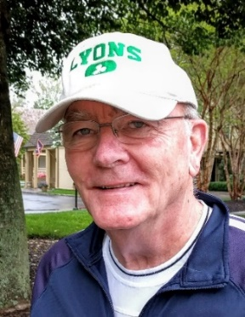
Merry Christmas and Happy New Year to all.

Thanks and adieu
Copy editor Elizabeth (Janie) Sherman has resigned her volunteer job with the LFA to return to her work as a certified genealogist. Janie has contributed her talent and experience to improve the quality of The Lyon’s Tale (LT), and I extend thanks to her on behalf of us all. If LFA members are looking for professional help in identifying ancestors, especially those from Virginia, contact Janie at societydame@verizon.net. Her website is http://augustagensearch.com

Ben Lyon, Movie Star
In this issue of the LT, you will find the fourth and final part of Barry Pavelec’s article about the life and family of the actor Ben Lyon. If you are not a big movie fan and have no relationship to Ben Lyon’s family, you may have decided to skip the first three parts of the article. I encourage you to read Part IV; it is enlightening and stirring. You are likely to become even more proud of your Lyon(s) brand. If you like what you read in Part IV, consider looking at Youtube (https://bit.ly/2EPaJcD) to see one of the 1954 episodes of This is Your Life with host Ralph Edwards where you will see and hear several people you read about in Part IV.

The Earls
Michael Hewitt fans who are looking for Part II of “The Earls of Kinghorne and Strathmore” will have to wait for the March issue of the newsletter. All of Mike’s articles for the LT have been based on material in his book, A Most Remarkable Family: A History of the Lyon Family from 1066 to 2014. See more about his book at Mike’s website: http://www.thelyonfamily.org.uk/purchases.html.

LFA Tour of Scotland - Part I
Jeannette Maxey, an LFA member and occasional contributor to the LT, went on the LFA sponsored trip to Scotland, and fortunately for those of us who didn’t make the trip, Jeannette is sharing her daily journal and her pictures. By the time we finish publishing her journal, I expect there will be a call for the association to plan another trip.

Isabel Lyon and Mark Twain
Perhaps the best-known author of American literature is Mark Twain. When Twain’s wife became ill, the author hired a young woman to take care of household chores. The woman was Isabel Van Kleek Lyon, and LFA historian Bruce Lyon has written an article about her and her relationship with the famous author. One side of the Twain-Lyon relationship is well documented by Twain in a 429-page manuscript that has only recently been made public.

Contest winners
In the past, whenever I might challenge LT readers with a question, I promised to send the winner an LFA t-shirt, if we ever got such shirts. In the last issue, we published a photograph of a distinguished looking man named Edward H. Lyon, and I said that we would send an LFA t-shirt to the first person to fully identify Edward. Foolish me; within 36 hours of distributing the September issue, Barry Pavelec, a foundation contributor to the LT, sent me sufficient evidence to win the as-yet unavailable LFA t-shirt. Barry identified the man in the picture as Edward Holden Lyon, son of Israel Whitney Lyon, the founder of Dr. Lyon’s Toothpowder. Bruce Lyon wrote about Dr. Lyon in an article that was published in the September 2013 issue of the LT.
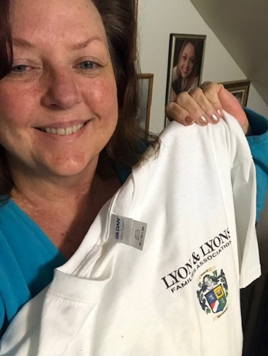
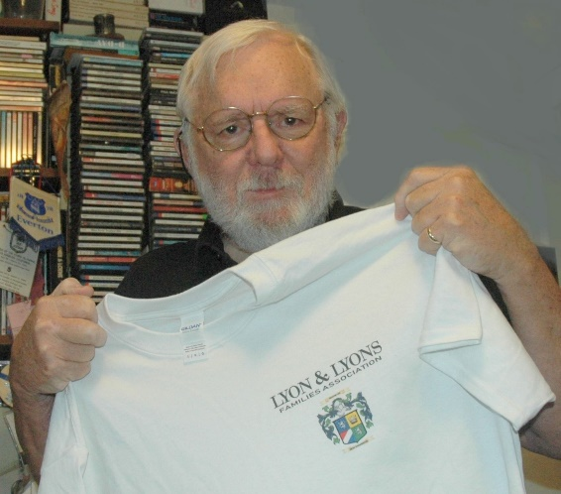
LFA president Mike Lyon led a small team to design an appropriate graphic for our association. Barry is pictured with his shirt, and Lori Lyons, who won the oldest living Lyon(s) contest, is pictured with her shirt. See more details about the graphic later in this issue.

Photos, DLLs, and Poetry
A few LFA members sensed my angst about the absence of Lyon(s) phots and sent me some pictures with identifying information. In this issue, you will find the submission of an old family photo from Barbara Munson. This issue also includes four Direct Lyon(s) Lineages. Once again, poet Maria Mazziotti Gillan has given us permission to reprint one of her poems. Maria has written 22 books of poetry and about poetry. She is the recipient of many awards for her work and is the Director of the Creative Writing Program and Professor of Poetry at Binghamton University-SUNY.

Copyreader Opening
The Lyon’s Tale has an opening for a copyreader. We – I – would like someone to read my final proof of each article before it is put into the LT. The copyreader will simply read the articles and look for obvious mistakes, such as: to for too, for for four, augusta for Augusta, a comma for a period, their for there, its for it’s, and so on and so so on. If you are reminded of the times you saw some of my bungles in earlier issues of the LT, consider yourself a candidate for the new position of LT copyreader. Your salary will be the same as mine. The prestige is incalculable. Think about it it.

